**TABLE OF CONTENT**

**ACKNOWLEDGEMENT**

**ABSTRACT**

**Keywords**

**CHAPTER 1**

**Introduction**

* 1. Study area
  2. Application Selection reason

1.3 Project description

1.4 Goals and objectives

1.5 Requirements Analysis

1.6 Scope of the project

1.7 Modules and their Description

1.8 Development and methodology

**CHAPTER 2**

**System Analysis**

2.1 Functional Requirements

2.2 Non-Functional Requirements

2.3 Feasibility Study

2.4 Requirements gathering and analysis

2.5 Proposed system

2.6 Design Principles for TTMS

**CHAPTER 3**

**System Design and architecture**

3.1 System architecture

3.2 Requirement specification

3.3 Software requirement

3.4 Relational database schema

3.5 Schema diagram

3.6 Process flowchart

3.7 Data flow diagram

3.8 Usecase diagram

3.9 Class diagram

3.10 Sequence diagram

3.11 Activity Diagram

3.12 ER model diagram

**CHAPTER 4**

**Database design and tables**

4.1 Description of tables

4.1.1 Account

4.1.2 Customer info

4.1.3 Book packages info

4.1.4 Book hotel

4.1.5 Hotels

4.2 Trigger

4.3 Stored procedure

**Chapter 5**

**Testing and result snapshot**

5.1 System integretion test plan

5.2 Testing

5.3 Result snapshot

5.4 Database design

5.5 Difficulties and solution

Conclusion

Future scope

**Travel And Tourism Management System**

**ACKNOWLEDGEMENT**

The Tours and Travel Management System is a web-based application. The main purpose of “Travel and Tourism Management System’” is to provide a convenient way for a customer to book vehicle or whole package to tour purposes. The objective of the project is to develop a system that automates the processes and activities of a travel agency. In the project will make an easier task of searching places and for booking facilities. In the present system a customer has to approach various agencies to find details of places and to book tickets. System often requires a lot of time and effort. The purpose of system is provided approach skills to critically examine how a tourist visits and its ability to operate in an appropriate way when dealing with the consequences of tourism, locally, regionally, and nationally including visitor security and ecological influences. System is tedious for a customer to plan a particular journey and have it executed properly. The project ‘Travel and Tourism Management System’ is developed to replace the currently existing system, which helps in keeping records of the customer details of destination as well as payment received.

**ABSTRACT**

The Main objective of this Travel & Tourism project is to make the travel easy and comfortable for the users right from finding the hotel and destination . In this project, we have a user module.

The user will register and log in and the find the appropriate hotel and use the id he will search the server by giving all details like hotel name and destination etc. After selecting the information user will be headed to booked hotel in a view the selected hotel will be displayed and then after successful payment the booking confirmation will be shown.

Keywords:-Travel and tourism management system, packages, hotels, destinations,

**Chapter 1**

**INTRODUCTION**

The purpose of website is established fact that Internet users are increasing today. One of the main purposes of the website is to facilitate the offline customer online because customers cannot spend their precious time in markets trying to find out the best deal. China is a country where in a few days holiday, you can enjoy a lot. The problem is that although having many websites but they offer different kind of services. The customers are enjoying a lot but there is a lack of relationship between travel agency and customers and hence establishing that relationship by caring and serving all customers in the same manner that wish to be served

* 1. **Study area**

The study area for a Travel and Tourism Management System encompasses the integration and management of various tourism-related services to enhance customer experiences. It includes functionalities such as customer registration, package browsing, hotel selection, destination information, and payment processing. The system aims to streamline operations for travel agencies by providing a centralized platform for managing customer data, booking details, and financial transactions. It also incorporates utility services like car rentals and travel insurance, ensuring comprehensive service offerings. By automating these processes, the system improves efficiency, reduces manual errors, and facilitates real-time updates. The study area focuses on leveraging technology to provide seamless, personalized travel planning and booking experiences, ultimately boosting customer satisfaction and operational effectiveness in the tourism industry.

* 1. **Application Selection reason**

The selection of a travel and tourism management system is pivotal for streamlining operations and enhancing customer experiences. This system enables efficient booking, real-time inventory management, and personalized services, significantly reducing manual workload and errors. It supports diverse functionalities such as itinerary planning, resource allocation, and customer relationship management, fostering seamless coordination among stakeholders. Moreover, the integration of advanced analytic provides valuable insights into customer preferences and market trends, facilitating data-driven decision-making. Ultimately, this system not only boosts operational efficiency but also enhances service quality, ensuring a competitive edge in the dynamic travel and tourism industry.

**1.3 Project description**

The main objective of the Tourism Management System is to manage the details of Customer, Hotel Booking, Cancellation and Tourism places. It manages all the information about Users, Hotel, Packages etc. The project is totally built at administrative end and thus only the administrator is guaranteed the access to the backend database. The purpose of this project is to build an application program to reduce the manual work for managing Tourists, Booking, Places etc.

This application will help in accessing the information related to the travel to the particular

destination with great ease. The users can track the information related to their tours with great ease through this application. The travel agency information can also be obtained through this

application. Through this system, the propose system is highly automated and makes the travelling activities much easier and flexible. The user can get the very right information at the very right time.

This system will include all the necessary fields which are required during online reservation time. This system will be easy to use and can be used by any person. The basic idea behind this project is to save data in a central database which can be accessed by any authorize person to get information and saves time and burden which are being faced by their customers.

Administrator can access and modify the information stored in the database of this system, this

includes adding and updating of details, and it will give accurate information and simplifies manual work and also it minimizes the documentation related work. Provides up to date information. Finally booking confirmation notification will be send to the users.

Tourists can register by providing personal details, make new reservation and book only one hotel

and package and can make cancellation.

**1.4 Goals and objectives**

1. To develop a web based application.
2. To provide best travelling services to the customers and travel agents.
3. To provide a search platform where a tourist can find their tour places according to

their choices.

1. To promote responsible and interesting tourism so that people can enjoy their holidays

at their favorable places.

1. To develop tourism with different cultures so that they enrich the tourism experience

and build pride.

1. To create and promote forms of tourism that provide healthy interaction opportunities

for tourists and locals and increase better understanding of different cultures, customs, lifestyles, traditional knowledge and believes.

7.To provide a better way to connect with various events

**1.5 Requirements Analysis**

Requirement is what a particular product must meet, which is an indispensable feature

of the product. Two being reasons for this: one is that products must obtain some

function and quality; the other is customers expect such requirement to be a part of

the products delivered. Requirements analysis includes a series of processes and its

ultimate goal is to locate a customer or user’s needs. After collecting, extracting

and summarizing the needs, the requirement will be patterned to form a requirement

specification, which serves as the foundation for following software development

sections.

Requirements analysis is receiving increasing attention and becomes a very long,

complicated section in project cycle, during which experts talk with their customers,

write down the conversation results, analyze the collected information, extract key

points, sum up a general concept, and then discuss the identified problems with the

customers. This process can be repeated and across the entire life cycle of some

projects.

Requirements specifications, documentation generated during the requirements

analysis section generally includes functional requirements, non-functional

requirements and design constraints, etc.

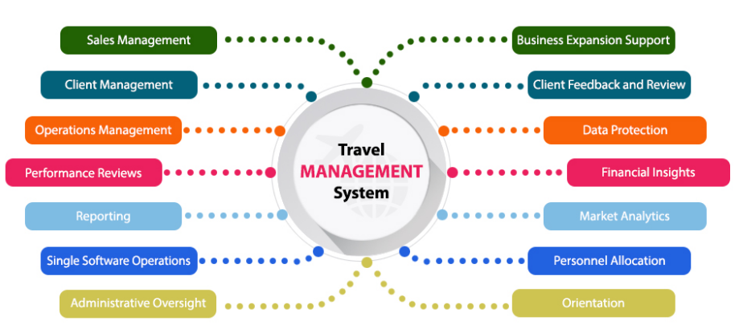

**1.6 Scope of the project**

The main purpose of “Travel and tourism management system” is to provide an alternate and convenient way for a customer to Search hotels, Book hotel, Find destination and Packages for tour purposes. In this project, I aim to choose that particular experience which will shape vision of the country by visiting our website. I will make an easier task of searching places and for booking train, flight or bus in future . I provide a Judgment and approach skills to critically examine how a tourist visits and its ability to operate in an appropriate way when dealing with the consequences of tourism, locally, regionally, and nationally including visitor security and ecological influences.

**1.7 Modules and their description**

**1. Customer Module**

Handles all customer-related activities and information.

**Features:**

1.Add Customer

2.Update Customer Details

3.View Customer Details

4.Delete Customer Details

**2. Packages Module**

Manages travel packages offered to customers.

**Features:**

1. Check Packages
2. Book Packages
3. View Packages

**3. Hotels Module**

Manages hotel bookings and information.

**Features:**

1.Book hotels

2.View hotels

3.View book hotels

**4. Destination Module**

Provides information about various travel destinations.

**5. Payment Module**

Handles all payment transactions within the system.

**Features:**

1. Pay using Paypal

**6. Utility Module**

Contains various utilities and tools that support the system’s functionality.

**Features:**

1. Notepad

2.Calculator

**7. About Us Module**

Provides information about the travel and tourism company.

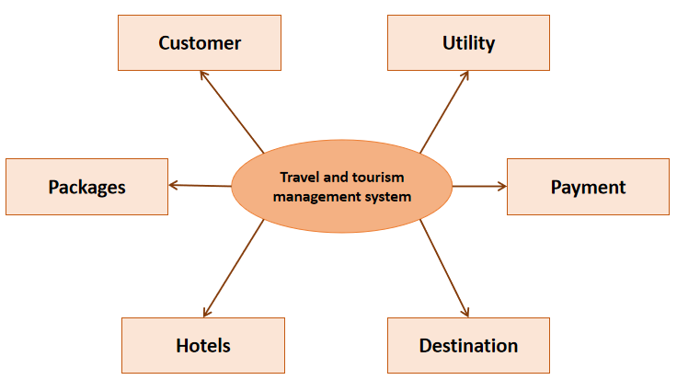

Fig: 1 Modules of the projects

**1.7 FEASIBILITY STUDY**

The feasibility study is undertaken to determine the possibility of either improving the present system or developing a completely new system. It helps to obtain an overview of the problem and get an idea whether a feasible solution exists.

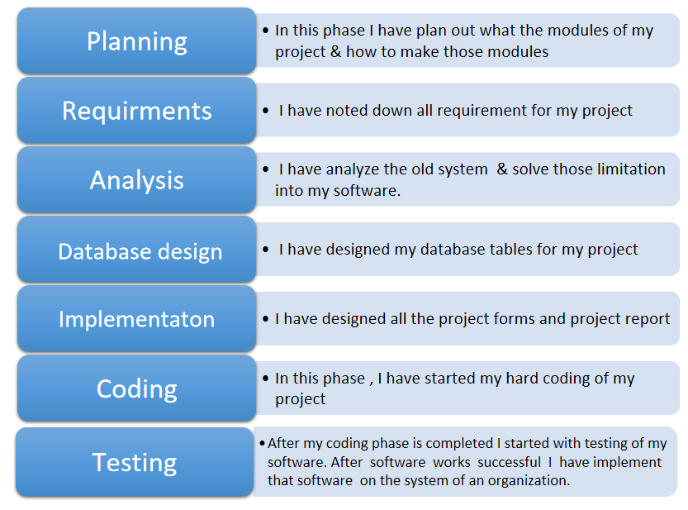

**CHAPTER 2**

**System Analysis**

A Travel and Tourism Management System (TTMS) streamlines booking, itinerary planning, and customer management. It integrates functionalities for hotels, tours, and offering a unified platform for service providers and customers. The system includes user-friendly interfaces for clients to search, compare, and book travel options, while backend tools assist agencies with inventory management, pricing, and customer relationship management. Real-time updates, secure payment gateways, and personalized services enhance user experience and operational efficiency. By leveraging data analytics, TTMS provides insights into customer preferences and market trends, driving targeted marketing and optimized resource allocation.

**2.1 Functional Requirements**

The travel and tourism management system must enable users to search, book, and manage travel services, including hotels, destinations, and tour packages. It should support user registration, secure login, and profile management. The system must provide real-time availability, pricing, and booking confirmation. It should offer payment processing with various methods, including credit cards and digital wallets. Users should receive automated notifications for bookings, changes, and cancellations. The system must include a review and rating feature for services.

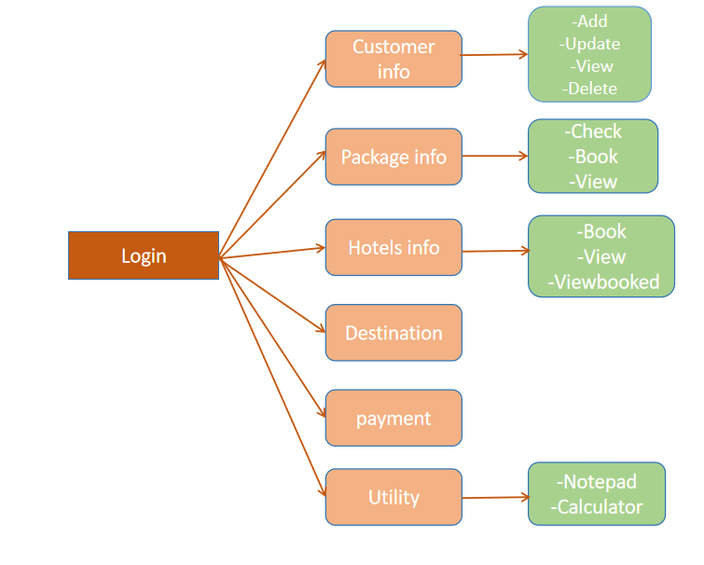

**2.2 Non-Functional Requirements**

Non-functional requirements for a travel and tourism management system are crucial to ensure its overall performance, reliability, and usability. These requirements typically include aspects such as:

**1. Performance:** The system should handle a large volume of concurrent users without significant slowdowns. Response times for critical functions like booking and information retrieval should be fast.

**2. Reliability:**It must be available 24/7 with minimal downtime for maintenance. Backup and recovery mechanisms should be in place to prevent data loss and ensure continuity of service.

**3. Security:** Robust measures must safeguard sensitive information such as personal details and payment data. Access control and encryption protocols should be implemented to protect against unauthorized access.

**4. Usability:** The system should be intuitive and user-friendly, catering to both novice users and travel professionals. Accessibility features should also be considered to accommodate users with disabilities.

**5. Scalability:** As the system grows, it should be able to accommodate increasing numbers of users and transactions without compromising performance.

1. **Compatibility:** It should integrate seamlessly with other travel-related systems and platforms to facilitate data exchange and enhance functionality.

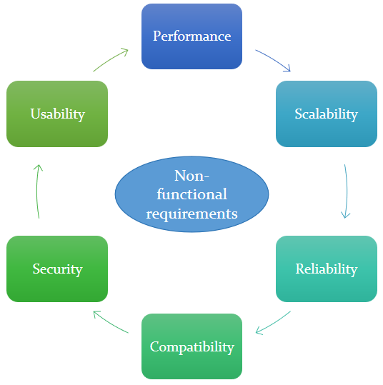

**2.3 Feasibility Study**

The feasibility study is undertaken to determine the possibility of either

improving the present system or developing a completely new system. It helps to

obtain an overview of the problem and get an idea whether a feasible solution

exists.

**1. Operational Feasibility Study :**

The current system is manual. Thus processing large amount of data

becomes a cumbersome activity. Reports that are generated are difficult to

prepare manually and are also error prone. Operationally the Proposed system

is feasibility because there are sufficient supports for project from management.

It will be running smoother and faster that of existing system.

**2.Technical Feasibility Study:**

Generally, new system brings new technology into an organization. The

proposed system requires technology and equipment, which can be obtained.

the operating system has the technical capacity to hold the data required to use

the proposed system. The present equipment technology assures technical

guarantee of accuracy, reliability and ease of access.

**3.Legal/Ethical Feasibility Study:**

Determines whether the proposed system conflicts with legal

requirements.

**4.Schedule Feasibility Study:**

A project will fail if it takes too long to be completed before it is useful.

Typically this means estimating how long the system will take to develop, and

if it can be completed in given time period using some methods like payback

period. Schedule feasibility is a measure of how reasonable the project

timetable is. Some projects are initiated with specific deadlines. You need to determine

whether the deadlines are mandatory or desirable.

**5. Resource Feasibility Study:**

This involves questions such as how much time is available to built the

new system, when it can be built, whether it interferes with normal business

operations, type and amount of resources required, dependencies.

**6.Cultural Feasibility Study:**

In this stage, the project's alternatives are evaluated for their impact on

the local and generated culture. For example, environmental factors need to be

considered and these factors are to be well known. Further an enterprise's own

culture can clash with the results of the project.

**2.4 Requirements gathering and analysis**

Requirements gathering and analysis for a travel and tourism management system involves identifying key functionalities such as booking management, itinerary planning, customer relationship management, and reporting. Understanding user roles—such as administrators, travel agents, and customers—is crucial. Features should include booking accommodations, transportation, and activities, along with payment processing and real-time availability updates. Integration with external APIs for services like weather forecasts and maps enhances usability. Security measures for handling personal and financial data are paramount. Additionally, the system should support multi-language and multi-currency capabilities to cater to diverse markets. User-friendly interfaces for both desktop and mobile platforms ensure accessibility.

**2.5 PROPOSED SYSTEM**

The proposed system is designed to be more efficient than the manual system. It invokes all base tasks that are now carried out manually, such as the forms transactions and reports which is added advantage. The proposed System is completely computer-based

application. Thousands of records can searched and displayed without taking any significant time

Advantages of the Proposed System:

* Gives accurate information
* Simplifies the manual work
* It minimizes the documentation related work
* Provides up to date information
* Friendly Environment by providing warning messages.
* travelers details can be provided
* booking confirmation notification

**2.6 Design Principles for TTMS**

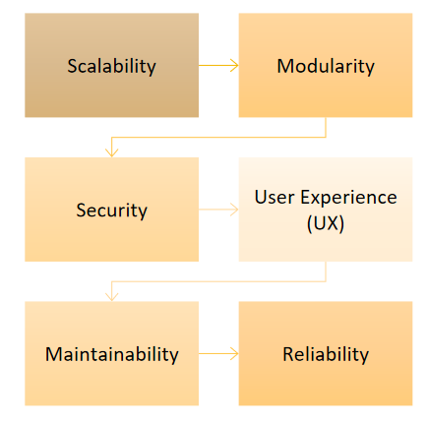

**1 .Scalability**

The architecture should handle increasing loads efficiently. Implement load balancing and auto-scaling features to manage traffic.

1. **Modularity**

Design the system in a modular way to allow easy maintenance, updates, and integration of new features.

1. **Security**

Implement strong authentication and authorization mechanisms. Encrypt sensitive data both at rest and in transit. Ensure compliance with data protection regulations like GDPR.

Optimize performance through caching strategies, efficient database queries, and content delivery networks (CDNs) for static resources.

1. **User Experience (UX)**

Design intuitive and responsive interfaces. Provide a seamless experience across different devices and platforms.

1. **Maintainability**

Follow coding standards and documentation practices. Use version control and continuous integration/continuous deployment (CI/CD) pipelines for smooth development and deployment cycles.

**6.Reliability**

Ensure high availability through redundant systems and fail-over strategies. Use monitoring and alerting tools to detect and respond to issues promptly.

**Chapter 3**

**System Design And Architecture**

* 1. **System Architecture**

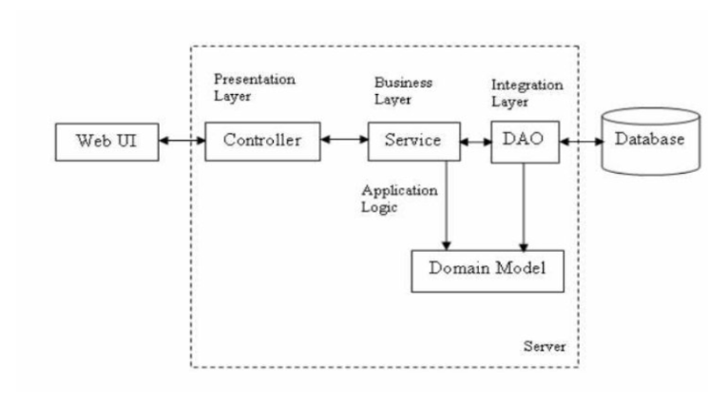

**1.Layered Architecture:**

* **Presentation Layer:** User interfaces for customers, travel agents, and administrators. This includes web and mobile applications.
* **Business Logic Layer:** Implements business rules and workflows for booking, itinerary planning, payment processing, and customer management.
* **Data Access Layer:** Manages data transactions between the business logic layer and the database.
* **Database Layer:** Centralized database management system storing user information, bookings, itineraries, payment details, and travel-related data.

1. **Microservices Architecture:**

* Services for different functionalities such as user management, booking, payments, and notifications. Each service can be developed, deployed, and scaled independently.

1. **API Gateway:**

* Acts as a single entry point for all client requests, directing them to the appropriate microservices.

1. **Cloud-Based Infrastructure:**

* Utilizes cloud services for scalability, flexibility, and cost-efficiency. Services like AWS, Azure, or Google Cloud can host the system.

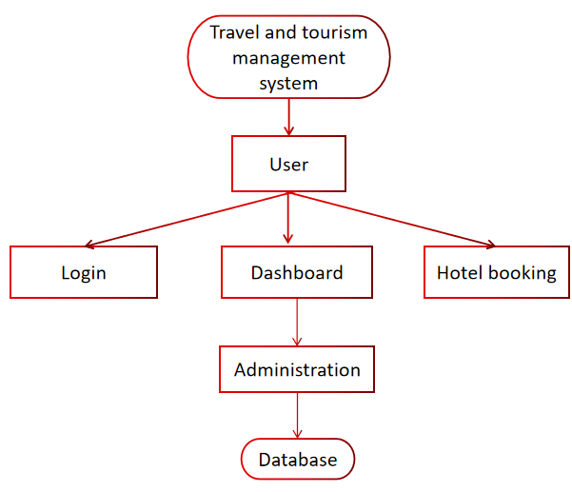

**3.2 Requirement Specification**

**Hardware Requirements**

Processor AMD Ryzen 3 3250U with Radeon Graphics 2.60 GHz

STORAGE Between 1.3 GB - 2.3 GB

RAM Minimum of 512 MB. The recommended amount can vary depending

on the number of users connected and other factors.

HARD DISK 3 GB of available hard-disk space for installation, additional free

space is required during installation

System type 64-bit operating system, x64-based processor

**3.3 Software Requirements**

**1. JDK 22**

JDK is an acronym for Java Development Kit. The Java Development Kit (JDK) is a software development environment which is used to develop java applications and applets. It physically exists. It contains JRE + development tools. JDK is an implementation of any one of the below given Java Platforms released by Oracle corporation: Standard Edition Java Platform,

Enterprise Edition Java Platform, Micro Edition Java Platform. The JDK contains a private Java Virtual Machine (JVM) and a few other resources such as an interpreter/loader (Java), a compiler (javac), an archiver (jar), a documentation generator (Javadoc) etc. to complete the development of a Java Application.

**2. mysql-connector-java-8.0.28.jar**

mysql-connector-java-8.0.28 is an application server designed to execute Java servlets and render web pages that use Java Server page coding. Accessible as either a binary or a source code version, it is been used to power a wide range of applications and websites across the Internet.As a Java Servlet container that provides extended functionality to interact with Java Servlets, It is a powerful option to execute Java servlets and render web pages that use Java Server page coding. It enables a pure Java web server Tourism Management environment, bringing together Java-based technologies to run applications built on Java programming language. While its flexibility and interoperability enable Apache Tomcat to behave as a web application server under certain conditions, its true identity is primarily as a Java servlet container.

**3 .MySQL Workbench**

MySQL Workbench is the official graphical user interface(GUI) tool for MySQL . It allows you to design,create and browse the database schemas , work with database objects and insert data as well as design and run SQL queries to work with stored data. We can also migrate schemes and data from other database vendors to your MySQL database.

**3.4 Relational Database Schema**

The data is stored in a database that is developed in MySQL. The database consists of two tables. Data of a tourist means details such as ID, name, from location, to location, no. of days and the price of tour package with ID as the primary key which is placed in a table tourpackage. The user table has the data like username and password for login that enables the admin to manipulate the

information regarding each tourist.

EER Diagram of Tourism Project Database

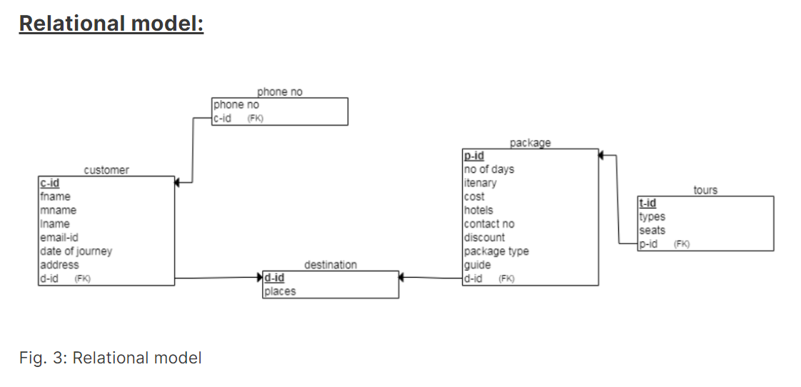

**3.5 SCHEMA DIAGRAM**

A database schema is the skeleton structure that represents the logical view of the entire database. It defines how the data is organized and how the relations among them are associated. It formulates all the constraints that are to be applied on the data.

A database schema defines its entities and the relationship among them. It contains a descriptive detail of the database, which can be depicted by means of schema diagrams. It’s the database designers who design the schema to help programmers understand the database and make it useful.

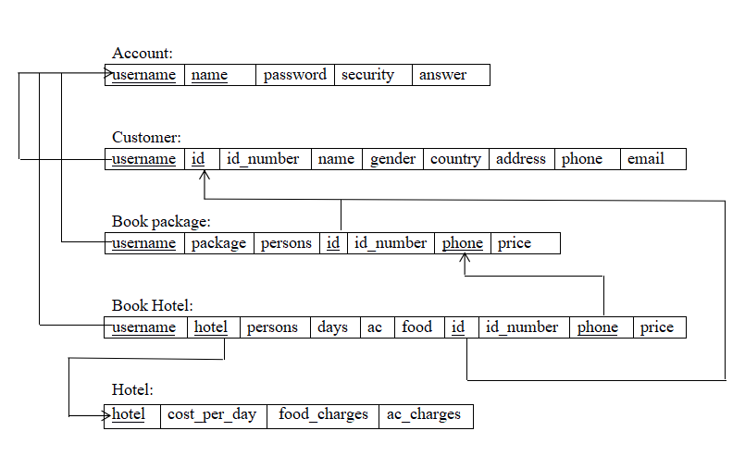

**3.6 Process Flowchart**

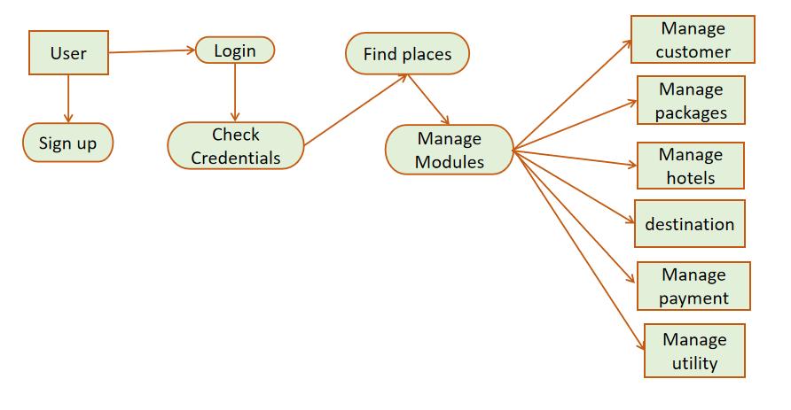

**3.7 Dataflow diagram**

It is also known as context diagram. The zero level DFD of tour and travel management system, where we have elaborated the high-level process of tourist management. It’s basic overview of the whole Management System or process being analyzed or modeled. It’s a designed to be an at-a-glance view of Transportation and tour.

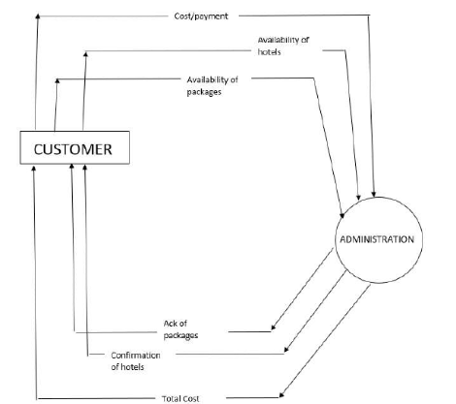

**DFD 1:**

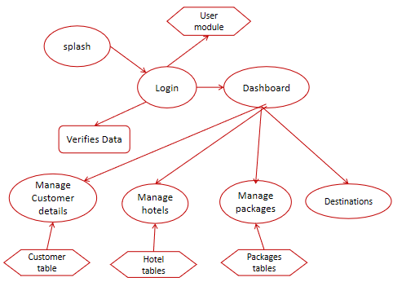

**DFD 2 :**

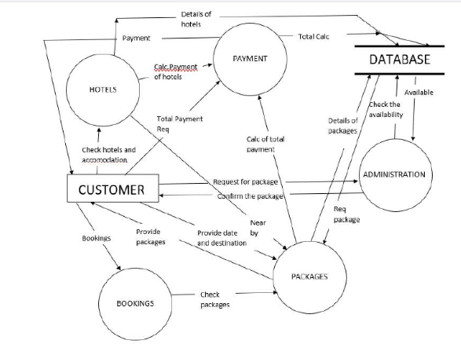

**3.8 Use-case Diagram**

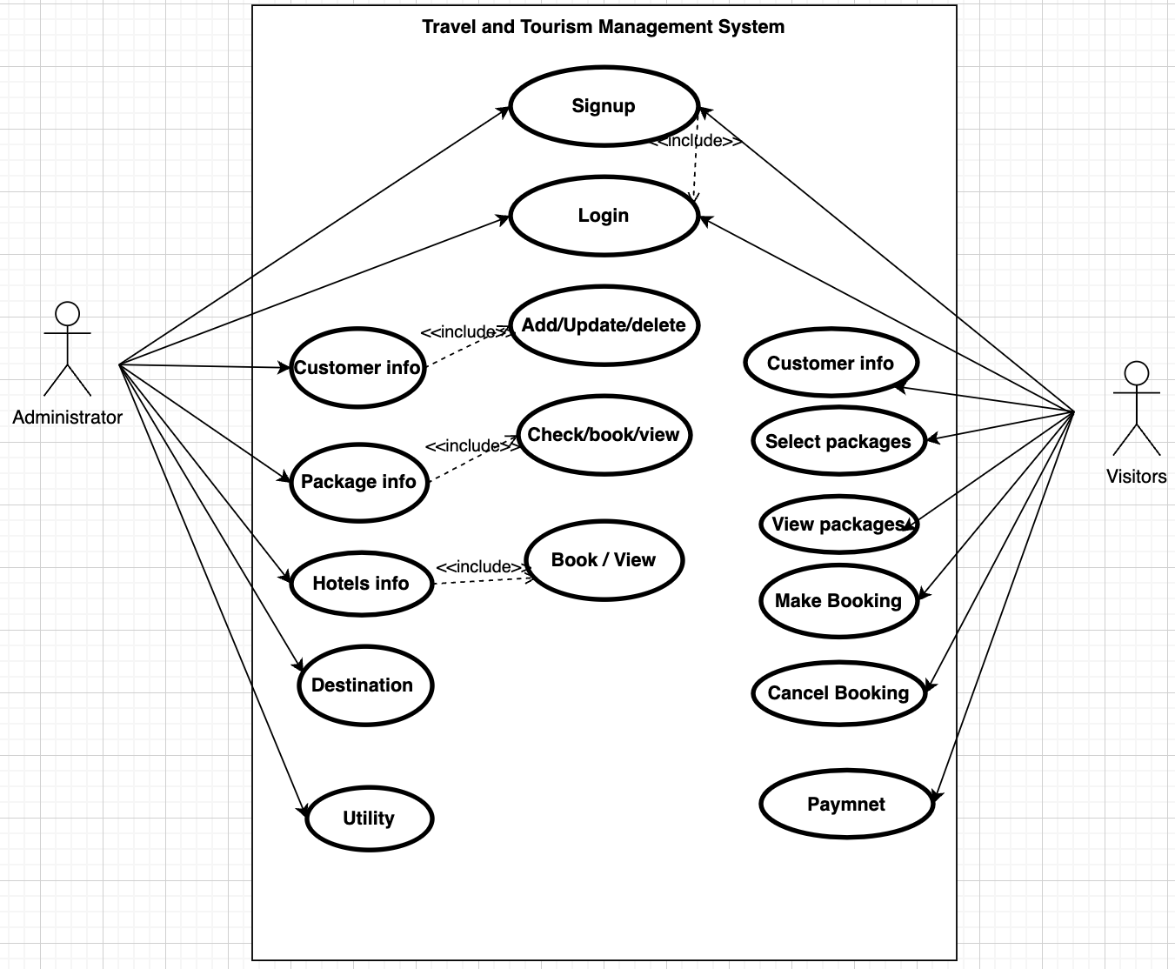

**3.9 Class Diagram**

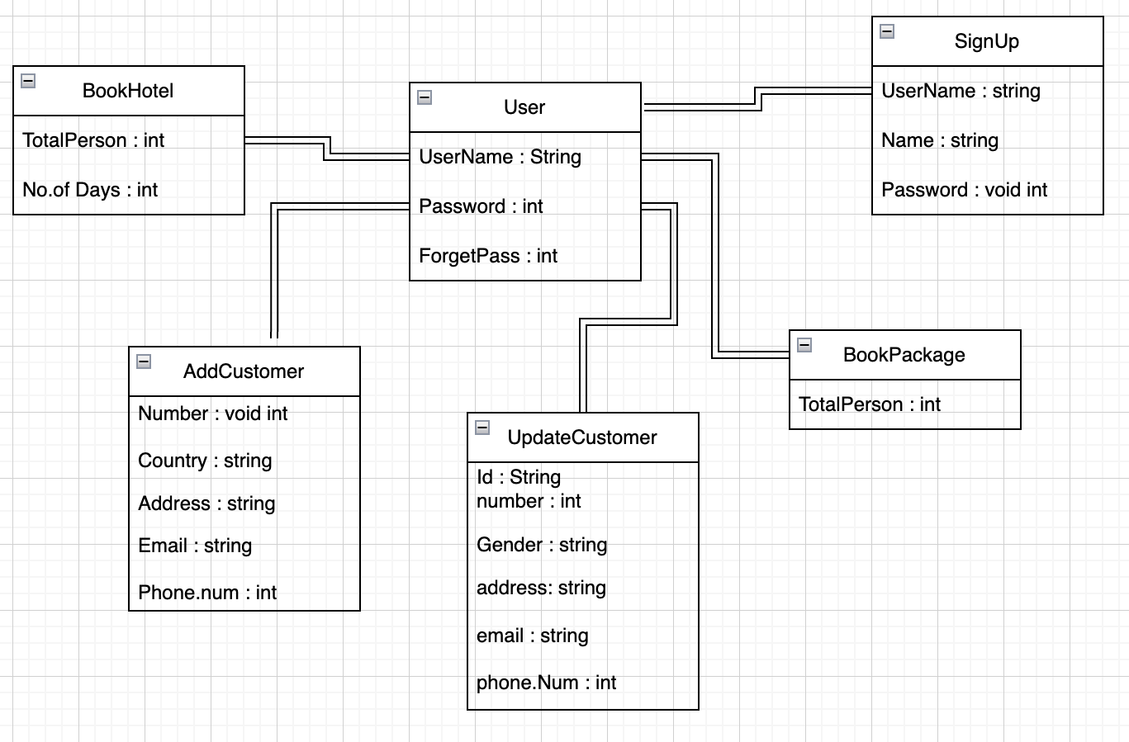

**3.10 Sequence Diagram**

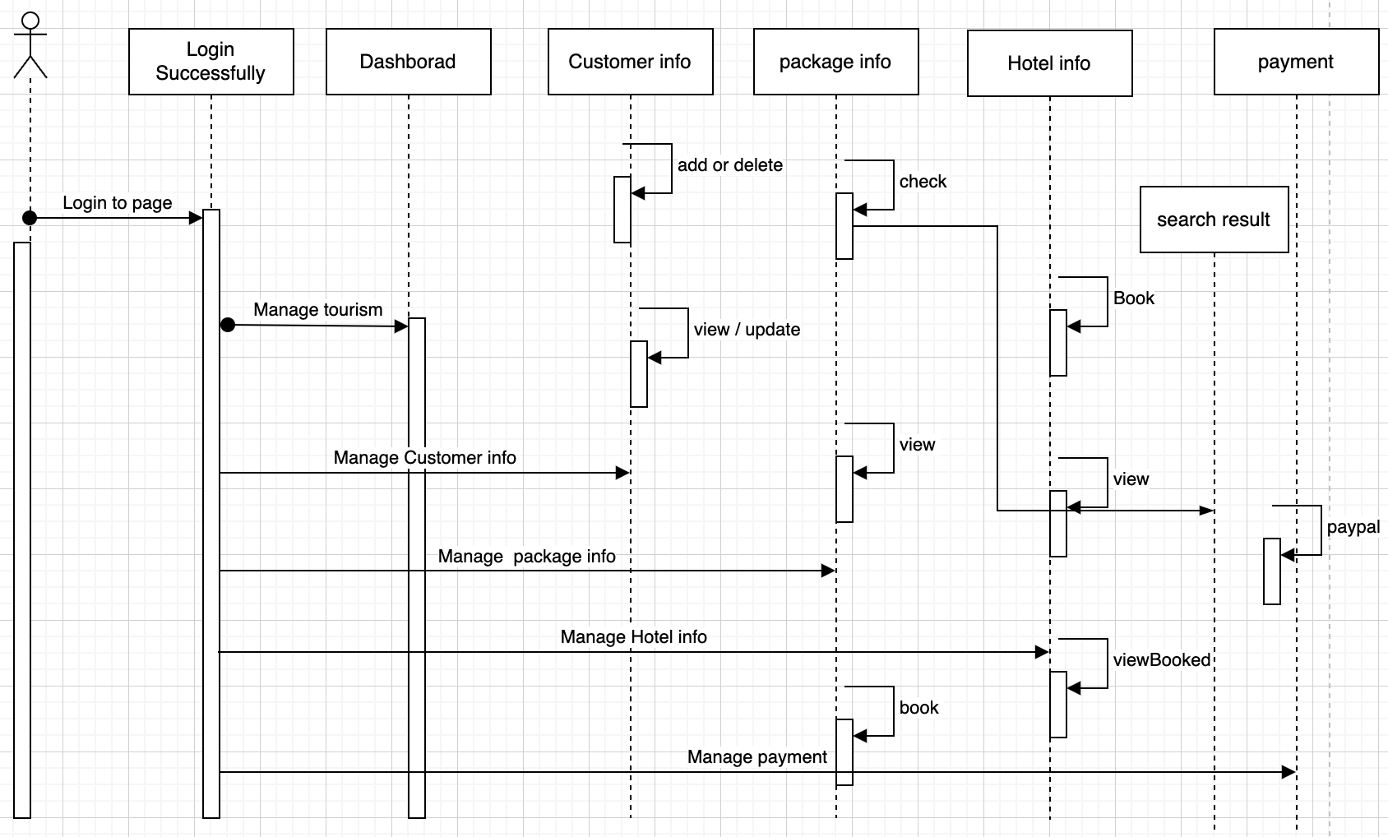

**3.11 Activity Diagram**

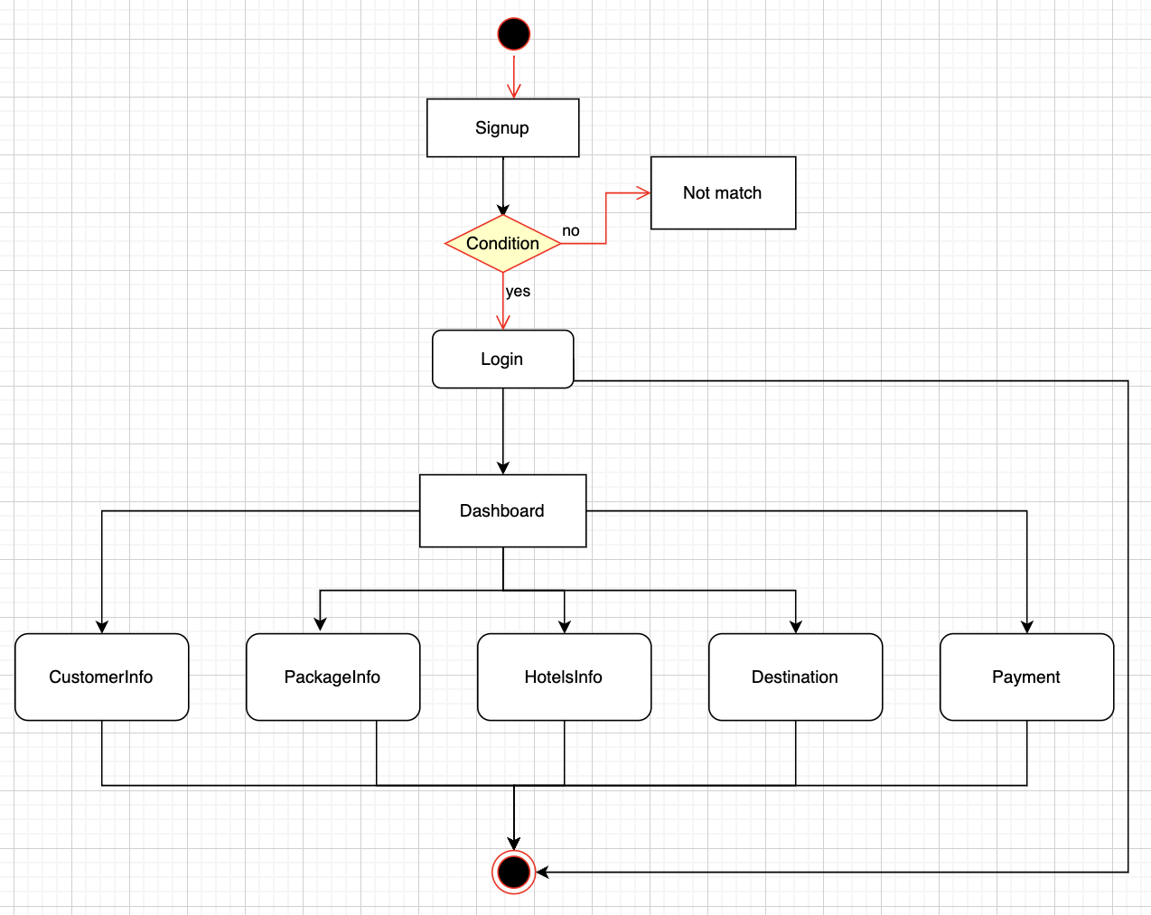

**3.12 ER model Diagram**

**ER Diagram** stands for Entity Relationship Diagram, also known as ERD is a diagram that displays the relationship of entity sets stored in a database. In other words, ER diagrams help to explain the logical structure of databases. ER diagrams are created based on three basic concepts: entities, attributes and relationships. ER Diagrams contain different symbols that use rectangles to represent entities, ovals to define attributes and diamond shapes to represent relationships.

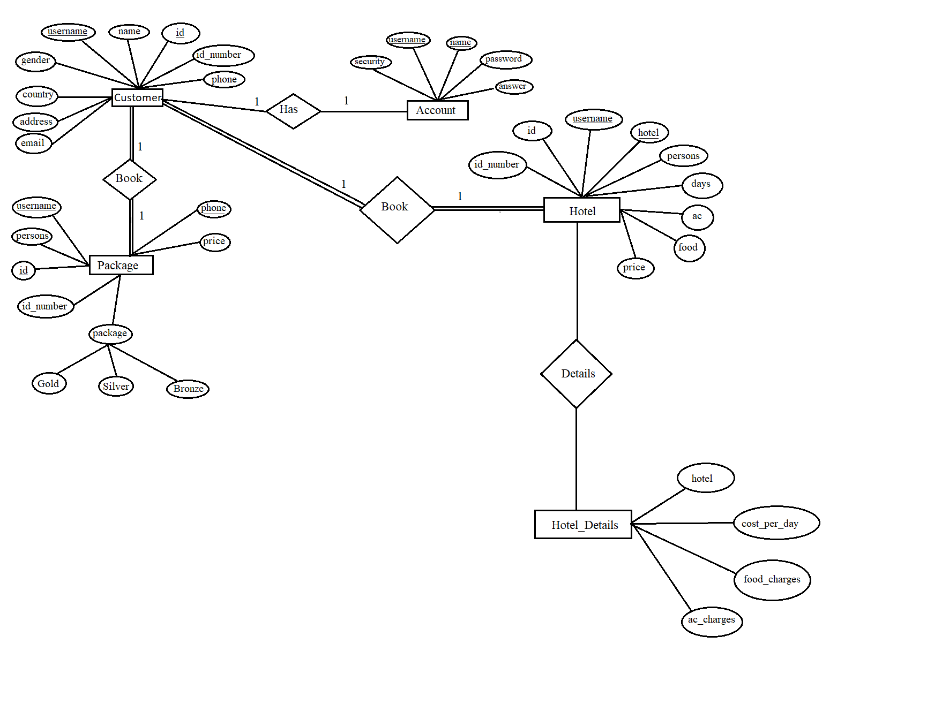

**Chapter 4**

**Database Design and table**

* 1. **: Description of tables**

**TABLE 4.1.1: ACCOUNT:**

|  |  |  |  |  |
| --- | --- | --- | --- | --- |
| **Field** | **Type** | **Null** | **Key** | **Default** |
| username | varchar(30) | NO | PRI | NULL |
| Name | varchar(30) | NO | PRI | NULL |
| password | varchar(30) | NO |  | NULL |
| security | varchar(30) | NO |  | NULL |
| Answer | varchar(30) | NO |  | NULL |

**TABLE 4.1.2: CUSTOMER:**

|  |  |  |  |  |
| --- | --- | --- | --- | --- |
| **Field** | **Type** | **Null** | **Key** | **Default** |
| username | varchar(30) | NO | MUL | NULL |
| id | varchar(30) | NO | PRI | NULL |
| id_number | varchar(30) | NO |  | NULL |
| name | varchar(30) | NO |  | NULL |
| gender | varchar(30) | NO |  | NULL |
| country | varchar(30) | NO |  | NULL |
| address | varchar(30) | NO |  | NULL |
| phone | varchar(30) | NO |  | NULL |
| email | varchar(30) | NO |  | NULL |

**TABLE 4.1.3: BOOK PACKAGE:**

|  |  |  |  |  |
| --- | --- | --- | --- | --- |
| **Field** | **Type** | **Null** | **Key** | **Default** |
| username | varchar(30) | NO | MUL | NULL |
| package | varchar(30) | NO |  | NULL |
| persons | int(10) | NO |  | NULL |
| id | varchar(30) | NO | MUL | NULL |
| id_number | varchar(30) | NO |  | NULL |
| phone | varchar(30) | NO | PRI | NULL |
| price | varchar(30) | NO |  | NULL |

**TABLE 4.1.4: BOOK HOTEL:**

|  |  |  |  |  |
| --- | --- | --- | --- | --- |
| **Field** | **Type** | **Null** | **Key** | **Default** |
| username | varchar(30) | NO | MUL | NULL |
| hotel | varchar(30) | NO | MUL | NULL |
| persons | int(10) | NO |  | NULL |
| days | int(10) | NO |  | NULL |
| Ac | varchar(30) | NO |  | NULL |
| food | varchar(30) | NO |  | NULL |
| Id | varchar(30) | NO | MUL | NULL |
| id_number | varchar(30) | NO |  | NULL |
| phone | varchar(30) | NO | MUL | NULL |
| price | varchar(30) | NO |  | NULL |

**TABLE 4.1.5: HOTEL:**

|  |  |  |  |  |
| --- | --- | --- | --- | --- |
| **Field** | **Type** | **Null** | **Key** | **Default** |
| hotel | varchar(30) | NO | PRI | NULL |
| cost_per_day | int(10) | NO |  | NULL |
| food_charges | int(10) | NO |  | NULL |
| ac_charges | Int(10) | NO |  | NULL |

* 1. **Trigger**

A trigger is a named database object that is associated with a table, and that activates when a particular event occurs for the table. Some uses for triggers are to perform checks of values to be inserted into a table or to perform calculations on values involved in an update. A trigger is defined to activate when a statement inserts, updates, or deletes rows in the associated table. These row operations are trigger events. A trigger can be set to activate either before or after the trigger event. For example, you can have a trigger activate before each row that is inserted into a table or after each row that is updated.

## Trigger used in this application:

## create trigger `trigger_on_login` after insert on `customer` for each row insert into users(username,id,id_number,name,country,gender,address,phone,email) values(NEW.username,NEW.id,NEW.id_number,NEW.name,NEW.country,NEW.gender,NEW.address,NEW.phone,NEW.email);

**4.3 STORED PROCEDURE**:

A stored procedure is a prepared SQL code that you can save, so the code can be reused over and over again. So, if you have an SQL query that you write over and over again, save it as a stored procedure, and then just call it to execute it. You can also pass parameters to a stored procedure, so that the stored procedure can act based on the parameter value(s) that is passed.

The most important part is parameters. Parameters are used to pass values to the Procedure. There are 3 different types of parameters, they are as follows:

* **IN:**  This is the Default Parameter for the procedure. It always receives the values from calling program.
* **OUT:** This parameter always sends the values to the calling program.
* **IN OUT:** This parameter performs both the operations. It Receives value from as well as sends the values to the calling program.

**Chapter 5**

**Testing and Result snapshot**

**5.1 System Integration Test Plan**

The major inputs and outputs and major functions of the system are follows:

**Inputs:**

• Tourist enters his Tourist id and password for login.

• New tourists give his completed personnel, address and phone details for registration.

• Tourist gives his customer id, hint question, answer for getting the forgotten password.

• Tourist search for hotels , book hotels , view hotels.

• Tourist search for packages , book packages and view packages.

**Outputs:**

• Tourist enter his or her own home page.

• The tourist-defined data can store in the centralized database.

• The new tourist’s data will be stored in the centralized database. •

• Tourist can get his forgot password.

**5.2 TESTING**

|  |  |  |  |  |  |  |
| --- | --- | --- | --- | --- | --- | --- |
| **Test cases**  **No.** | **Test case** | **Input Data** | **Steps to execute the test case** | **Expected Result** | **Actual Result** | **Pass/Fail** |
| **1** | Login Screen | Wrong username or password | After entering the data click  on the login button | A proper message indicating the error should appear and the user should be redirected to login screen. | A message  was displayed saying Invalid username or password | Pass |
| **2** | Insertion | If any field was not entered. | After entering the data click  on the create button | A proper message indicating the error should appear and the user should be redirected to customer screen. | A message  was displayed saying Enter all the details properly | Pass |
| **3** | Deletion | If any field was not entered. | After entering the data click  on the delete button | A proper message indicating the error should appear and the user should be redirected to customer screen. | A message  was displayed saying Enter all the details properly | Pass |
| **4** | Update | If any field was not entered. | After entering the data click  on the update button | A proper message indicating the error should appear and the user should be redirected to update customer screen. | A message  was displayed saying Enter all the details properly | Pass |

**5.3 Result snapshot**

**5.1.1. Login**

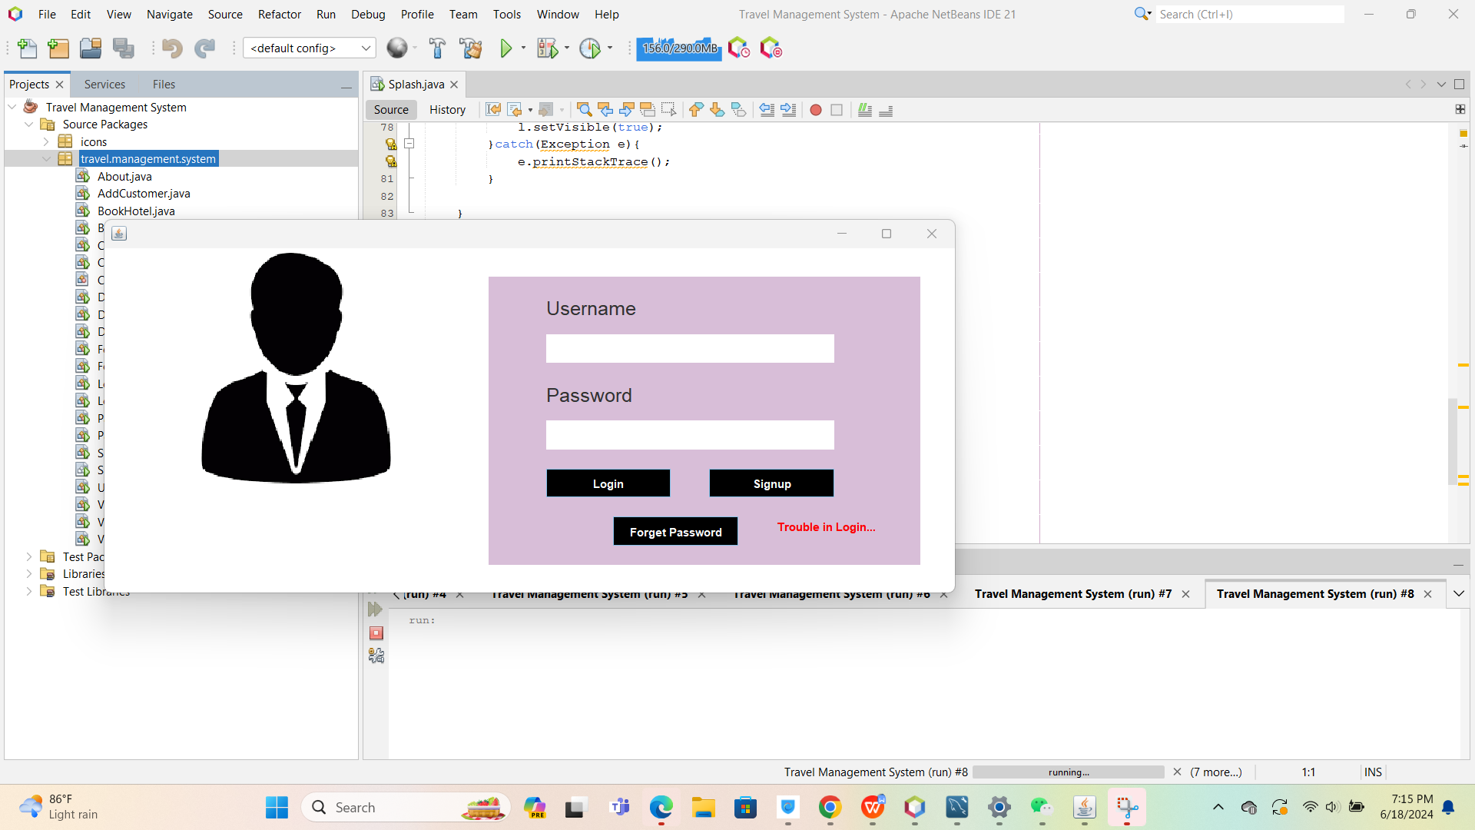

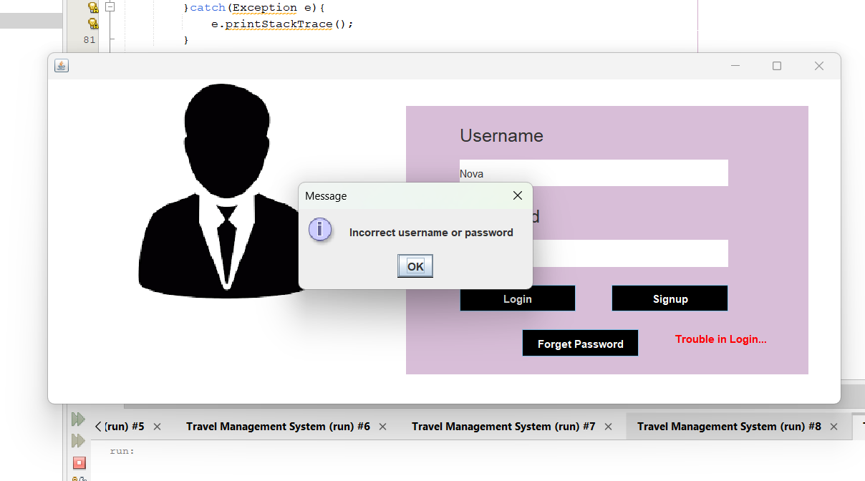

Login failed . because I did not include the info in the database. So next step I will signup the user info.

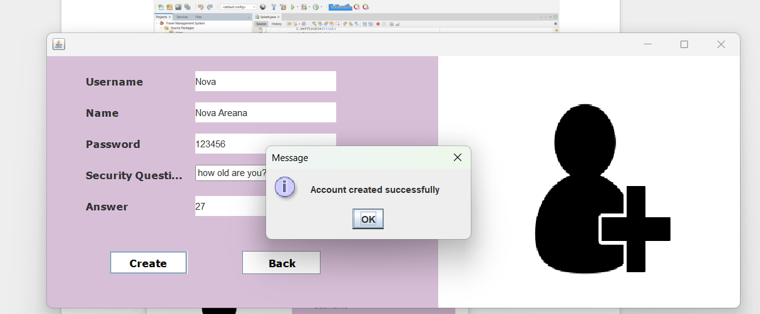

Let’s Login again .

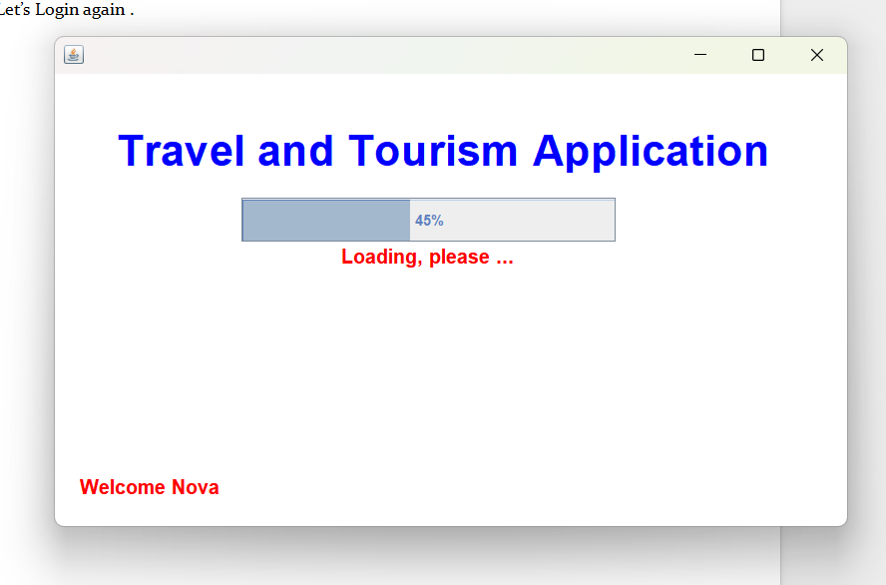

Logged in successfully

**2.Dashboard :**

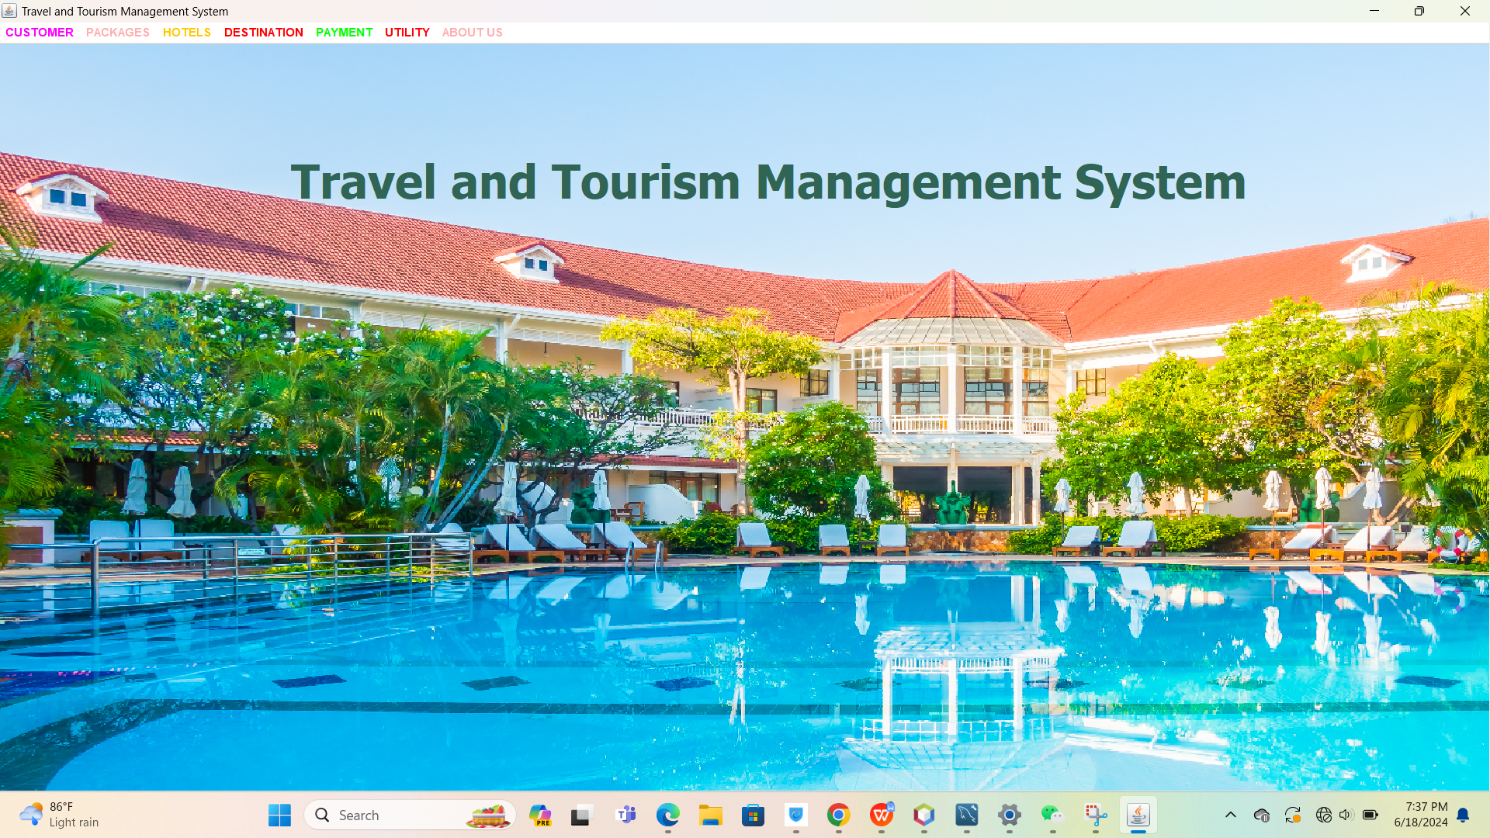

.

**3.Customer info**

**Add customer**

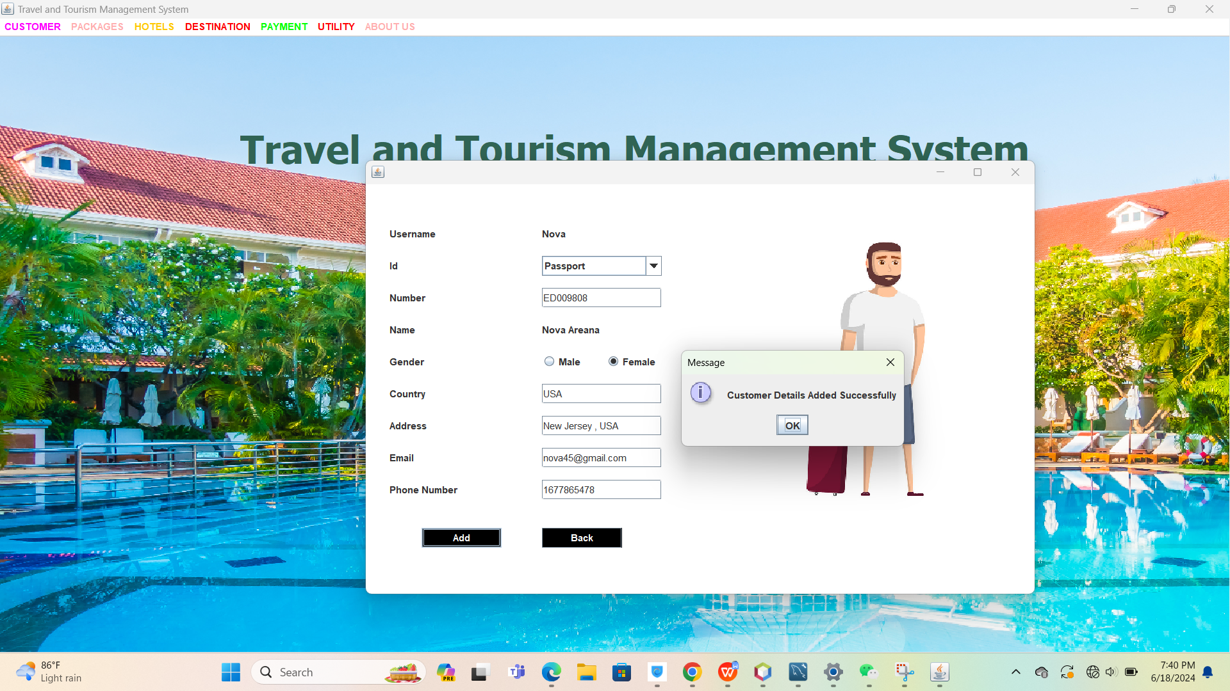

Successfully stored the info in the SQL database.

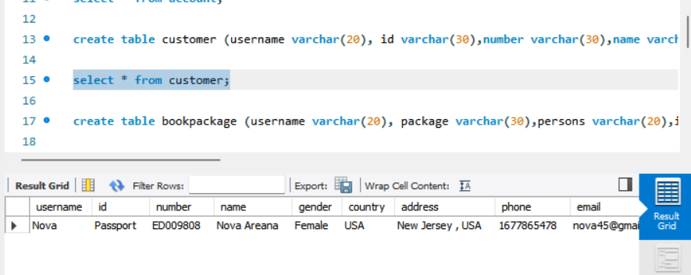

**View Customer info**

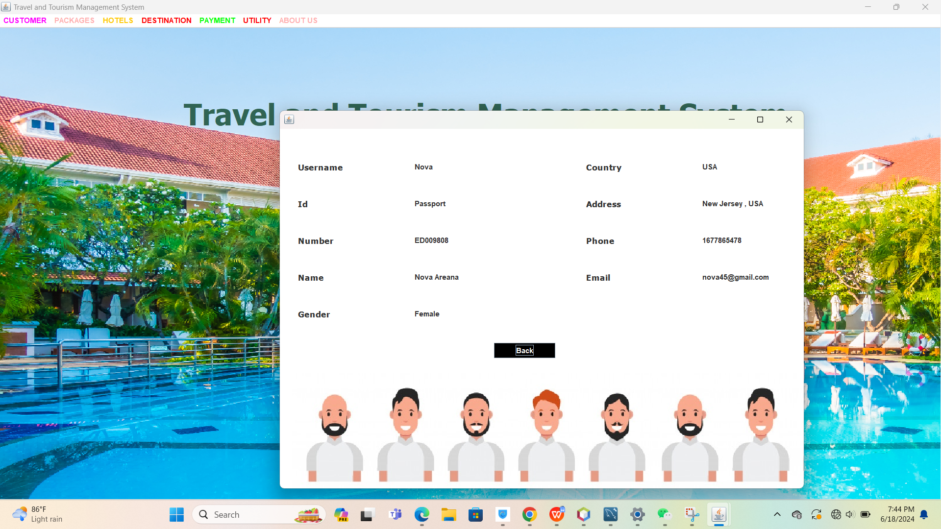

**Update customer**

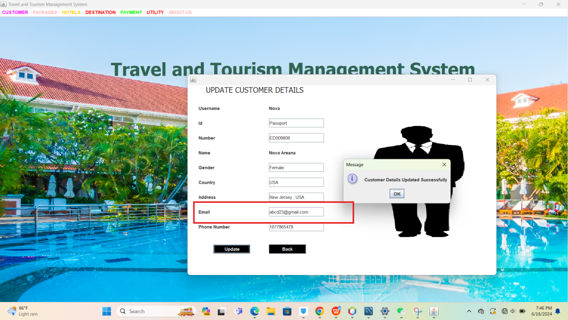

1. **Packages**

**Check packages**

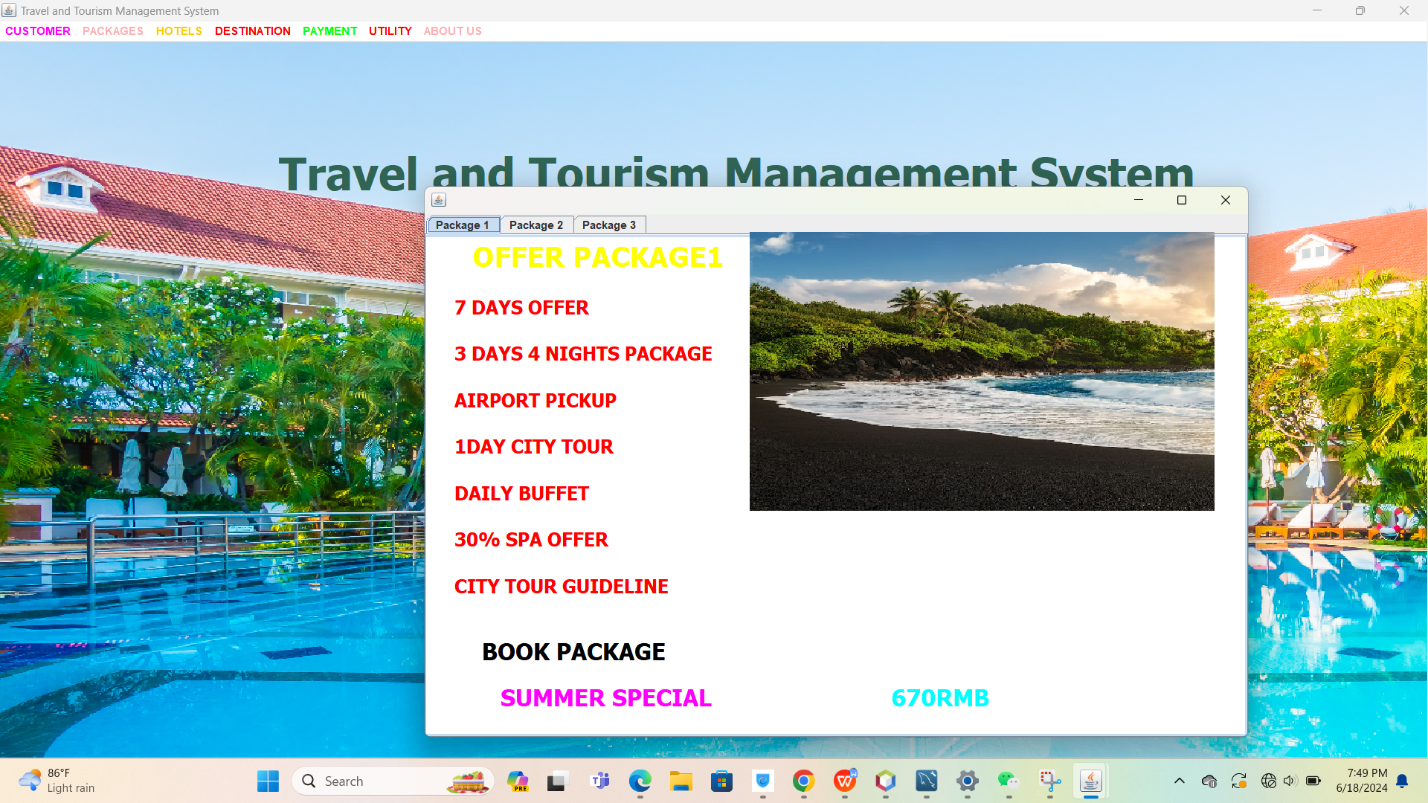

**Book packages**

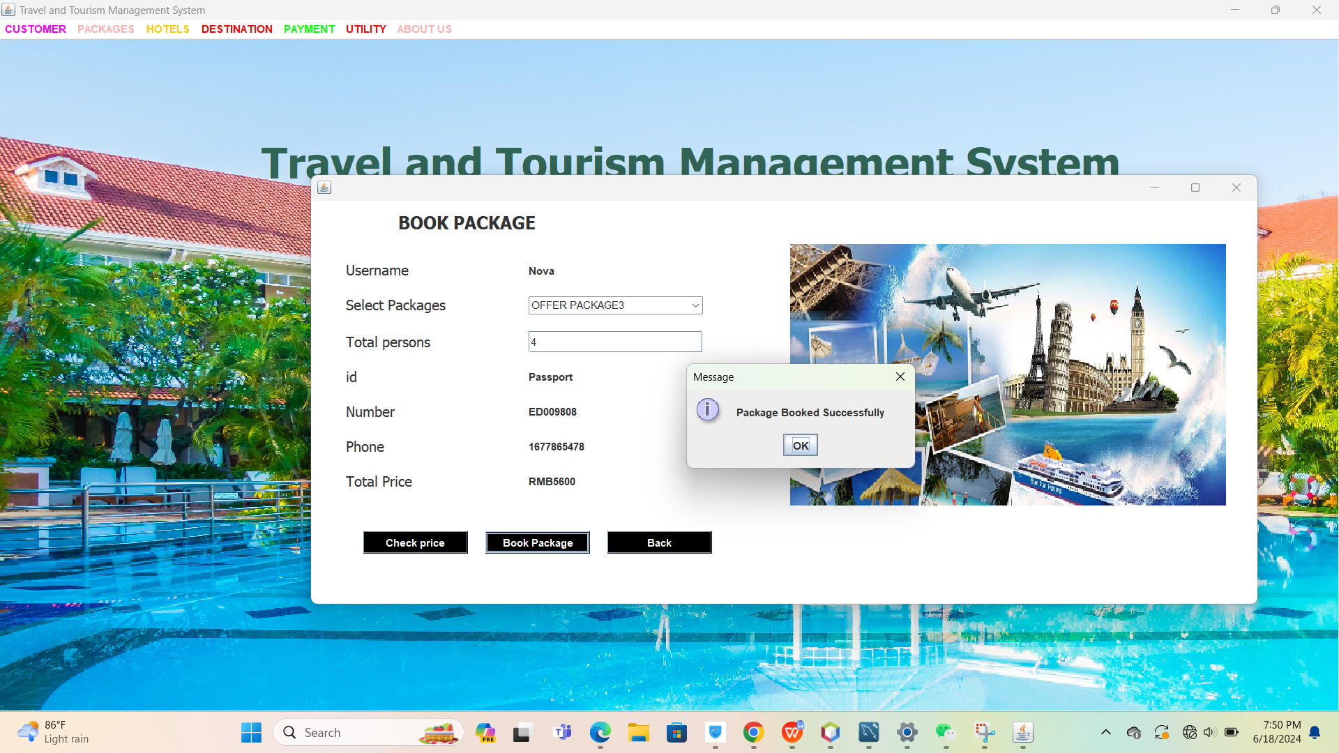

**View Boooked Packages**

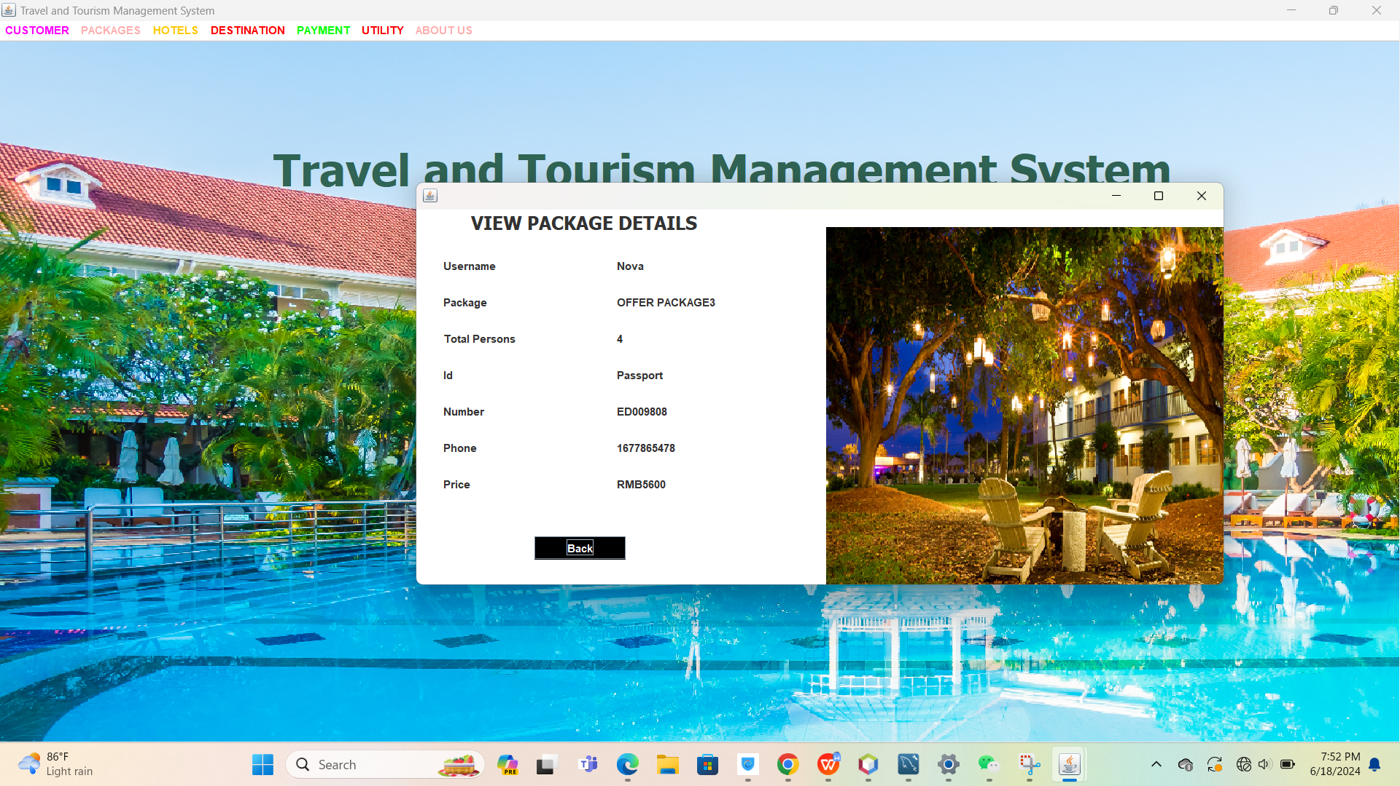

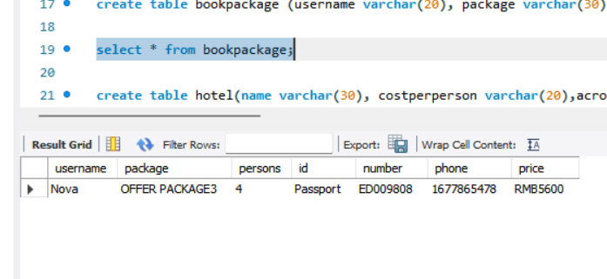

1. **Hotels**

**Book hotel**

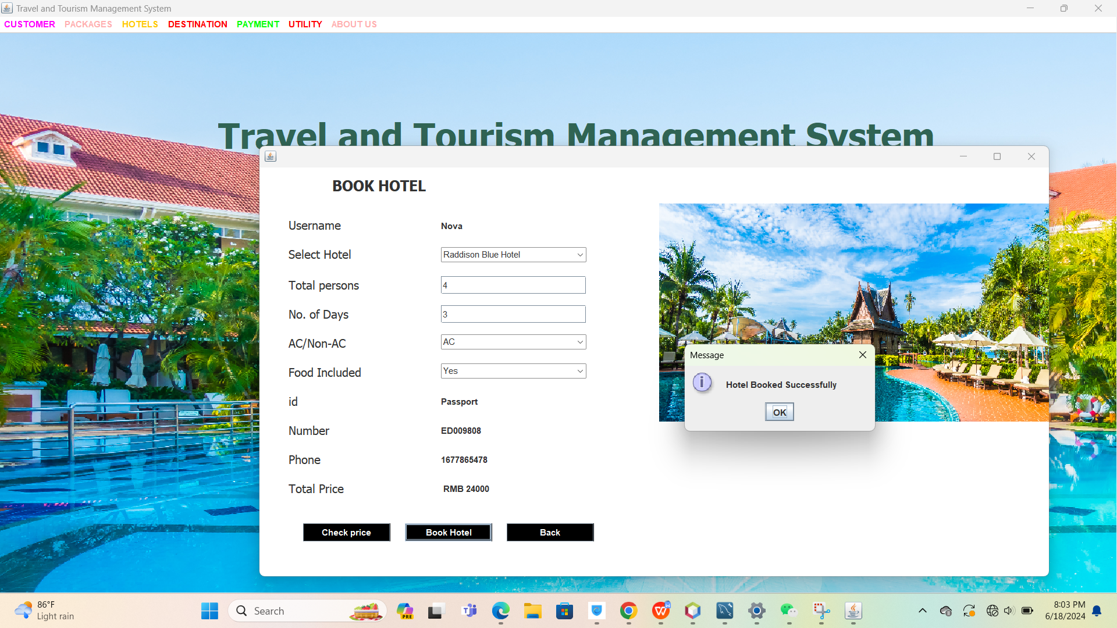

**View hotel**

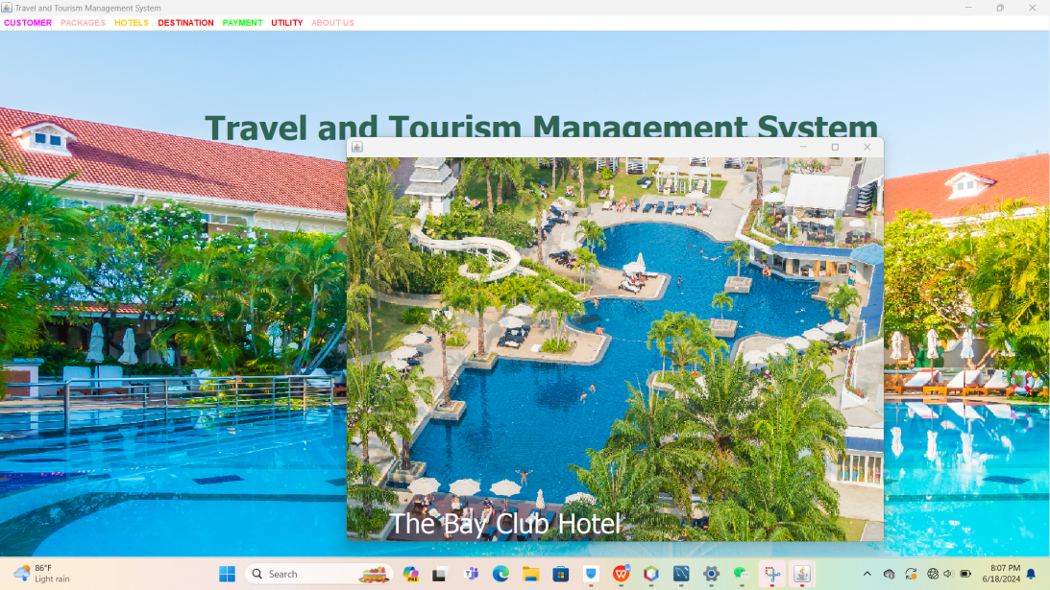

**View booked hotel**

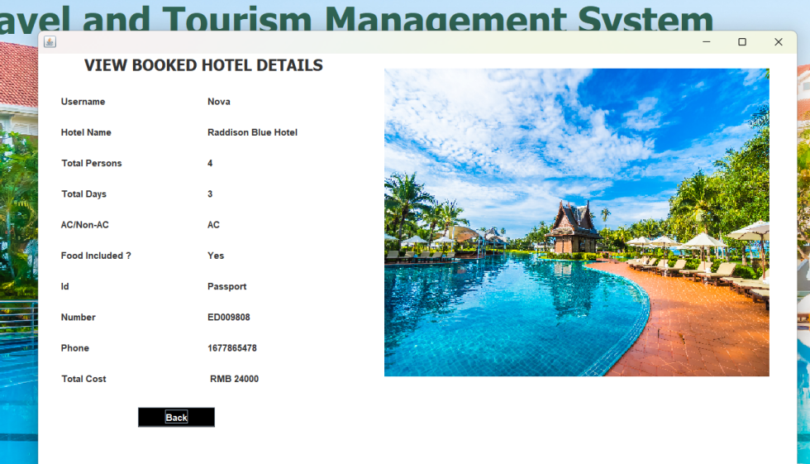

1. **Destination**

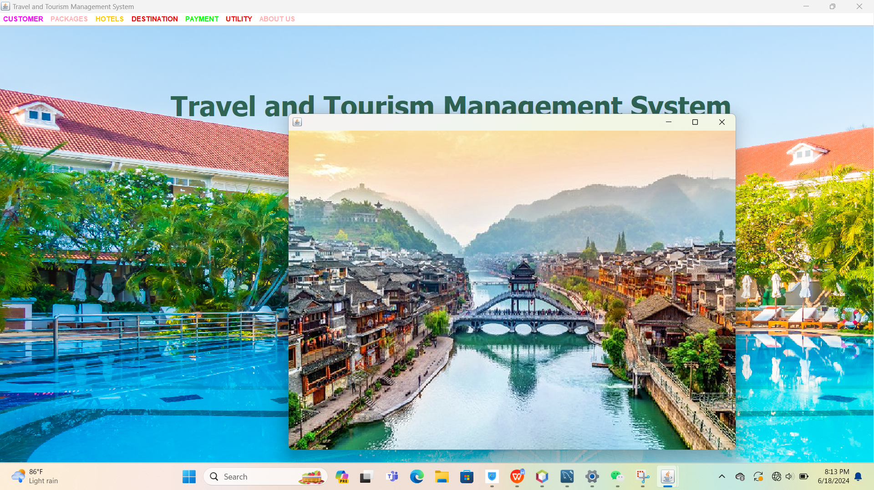

1. **Payment**

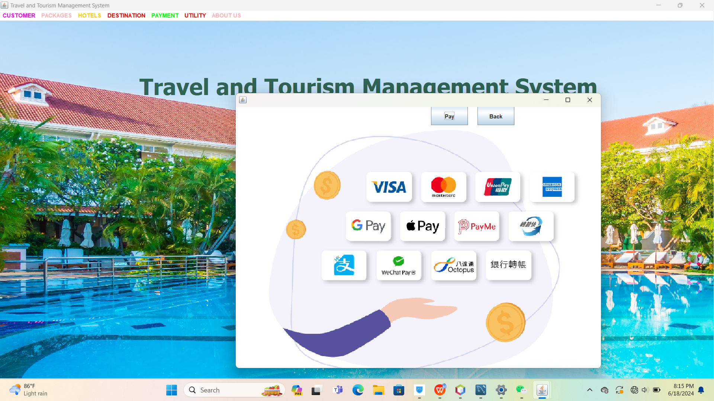

**8.Utility**

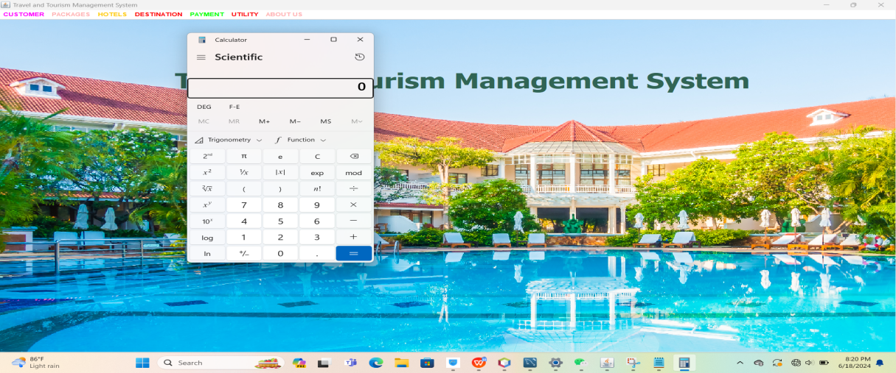

**5.4 Database Design**

create database travelmanagementsystem;

show databases;

use travelmanagementsystem;

create table account (username varchar(20),name varchar(20),password varchar(20),security varchar(100),answer varchar(50));

show tables;

select * from account;

create table customer (username varchar(20), id varchar(30),number varchar(30),name varchar(30),gender varchar(20),country varchar(30),address varchar(50),phone varchar(15),email varchar(40));

select * from customer;

create table bookpackage (username varchar(20), package varchar(30),persons varchar(20),id varchar(30),number varchar(30),phone varchar(20),price varchar(20));

select * from bookpackage;

create table hotel(name varchar(30), costperperson varchar(20),acroom varchar(10),foodincluded varchar(10));

insert into hotel values ('Raddison Blue Hotel','500','1000','500');

insert into hotel values ('The Golden Dynasty','800','1200','700');

insert into hotel values ('Ramada Plaza','400','800','400');

insert into hotel values ('Meridian Hotel','560','1100','400');

insert into hotel values ('Royal China','800','1300','630');

insert into hotel values ('The Bay Club Hotel','650','860','500');

insert into hotel values ('Hotel Orange','500','1000','400');

insert into hotel values ('Mandarin Palace','400','800','400');

insert into hotel values ('Nothern Star','340','600','500');

insert into hotel values ('The Horizon','500','940','430');

select * from hotel ;

create table bookhotel(username varchar(20), name varchar(30),persons varchar(10),days varchar(10),ac varchar(10),food varchar(10),id varchar(20),number varchar(20),phone varchar(20),price varchar(20));

select * from bookhotel;

**5.5 Difficulties and solution**

**1. Data Management**

**Difficulty:** Handling large volumes of data such as bookings, customer details, and travel

itineraries.

**Solution:** Implement efficient database management with indexing and data normalization to ensure quick retrieval and storage.

**2. User Interface**:

**Difficulty:** Designing an intuitive and user-friendly interface for diverse user groups.

**Solution:** Employ user-centered design principles, conduct usability testing, and iterate based on user feedback.

1. **Integration with External Systems:**

**Difficulty:** Integrating with third-party services like payment gateways, airline APIs, and hotel booking systems.

**Solution:** Use well-documented APIs, ensure secure data exchange, and handle API rate limit and downtime gracefully.

1. **Security:**

**Difficulty:** Protecting sensitive user data from breaches and ensuring secure transactions.

**Solution:** Implement robust security measures including SSL/TLS, data encryption, and

regular security audits.

**Conclusion**

In this project I have tried my best to make user friendly software. This software can be handled by any person who has little bit of idea of computers. In this software I

have tried to meet most of the requirements of the present hotel management system including maintaining details of customers, Hotels , packages and payment. I also keep

provision to update the details of customers, booked hotels and so on. In my effort I

have tried to make my software all the more user friendly but there may some featureswhich I would like to include in my continuous attempts.

**Future Scope**

The process of the system we can consider here, can maintain the databases of the

system. We can insert to the databases and retrieve all the information. The main aim of this project is to help the tourists to manage their trip. It makes all operation of thetour company easy and accurate. The standalone platform makes tourism management

easy by handling requests and providing servers for the customers located at different

parts of the various cities. Different modules have been incorporated in this project to handle different parts and sector of the tour management field.